Adding GTM
Placement:
Dev / Staging -
- Paste this code as high in the <head> of the page as possible:
<!-- Google Tag Manager -->
<script>(function(w,d,s,l,i){w[l]=w[l]||[];w[l].push({'gtm.start':
new Date().getTime(),event:'gtm.js'});var f=d.getElementsByTagName(s)[0],
j=d.createElement(s),dl=l!='dataLayer'?'&l='+l:'';j.async=true;j.src=
'https://www.googletagmanager.com/gtm.js?id='+i+dl;f.parentNode.insertBefore(j,f);
})(window,document,'script','dataLayer','GTM-MSX7R7F4');</script>
<!-- End Google Tag Manager -->

- Paste this code immediately after the opening <body> tag:
<!-- Google Tag Manager (noscript) -->
<noscript><iframe src="https://www.googletagmanager.com/ns.html?id=GTM-MSX7R7F4"
height="0" width="0" style="display:none;visibility:hidden"></iframe></noscript>
<!-- End Google Tag Manager (noscript) -->

Production:
- Paste this code as high in the <head> of the page as possible:

<!-- Google Tag Manager -->
<script>(function(w,d,s,l,i){w[l]=w[l]||[];w[l].push({'gtm.start':
new Date().getTime(),event:'gtm.js'});var f=d.getElementsByTagName(s)[0],
j=d.createElement(s),dl=l!='dataLayer'?'&l='+l:'';j.async=true;j.src=
'https://www.googletagmanager.com/gtm.js?id='+i+dl;f.parentNode.insertBefore(j,f);
})(window,document,'script','dataLayer','GTM-NXWW7L3J');</script>
<!-- End Google Tag Manager -->

- Paste this code immediately after the opening <body> tag:
<!-- Google Tag Manager (noscript) -->
<noscript><iframe src="https://www.googletagmanager.com/ns.html?id=GTM-NXWW7L3J"
height="0" width="0" style="display:none;visibility:hidden"></iframe></noscript>
<!-- End Google Tag Manager (noscript) -->

DataLayer Push
Placement: This code must be placed above the GTM <script> tag in the <head> of the document.

Object Path |  |  |  | Key | Data Type | Example | Notes
root |  |  |  | event | string | "page_init" | Bootstrap event. Fires once per page load.
environment |  |  |  | env | string | "production" | Controlled values: production, staging, qa, dev
environment |  |  |  | site | string | "gsusa_shop" | Stable site identifier. Low-cardinality.
environment |  |  |  | platform | string | "web" | Controlled values: web, mweb, ios_app, android_app
environment |  |  |  | version | string | "1.42.0" | Release/app version. Useful for debugging.
page |  |  |  | page_type | string | "store locator" | Controlled taxonomy (homepage, plp, pdp, cart, checkout, confirmation, search, account, etc.).
page |  |  |  | page_name | string | "store locator " | Stable internal page label. Not display copy. naming convention council – {{ council name }}
page |  |  |  | path | string | "/" | Should use window.location.pathname.
page |  |  |  | referrer | string | "https://google.com" | Use document.referrer. May be empty.
page |  |  |  | previous_page_path | string | "/checkout/confirmation" | Internal previous path if available. Do not infer from referrer.
page |  |  |  | title | string | "Girl Scouts Shop" | Use document.title.
page |  |  |  | language | string | "en-US" | From <html lang> or browser.
user |  |  |  | login_state | string | "logged_out" | Controlled: logged_in, logged_out
user |  |  |  | user_id | string | "u_7f3a91c2" | Gigya ID. Not email-derived. Null if not logged in.
user |  |  |  | user_type | string | "new_user" | Controlled: guest | new_user | returning_user | returned_customer – set to new new_user if account was created in the same day as session, returning_user if the user has no orders, returned_customer more than 1 order default to guess if non-known user
user | customer_type | string | "consumer" | Controlled: consumer, council administrator, vendor – be default set consumer, once the user identified based on login status or UX experience
user |  |  |  | audience_mode | string | "leaders” | Controlled: leaders | general. Set to leader if user toggles leader UX experience otherwise general

window.dataLayer.push({
event: "page_init",
environment: {
env: "production",
site: "gsusa_shop",
platform: "web",
version: "1.42.0"
},
page: {
page_type: "store locator",
page_name: "store locator",
path: window.location.pathname,
referrer: document.referrer,
previous_page_path: "/",
title: document.title || null,
language: document.documentElement.lang || navigator.language || null
},
user: {
login_state: "logged_out",
user_id: null,
user_type: "guest"
customer_type: "council administrator",
audience_mode: "leaders"
}

Store Search
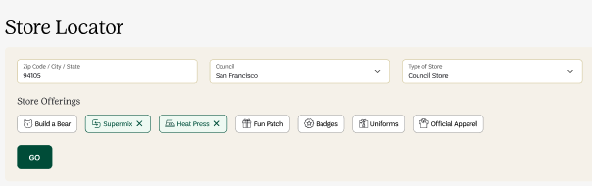

Object | Parameter Name | Data Type | Example Value | Description
root | event | string | "search" | Event name pushed to dataLayer
search | search.term | string | "90066-San Francisco-CA|Badges-Fun Patch " | Search input Format: {{zip}}-{{council}}-{{State}}|{{list of store offerings with “-“ delimiter
search | search.method | string | "manual" | How the search was initiated (manual input, selector, autocomplete, guided nav)
search | search.destination | string | "/storelocator" | Destination of search results
search | search.location | string | "header" | Page location where search was initiated
search | search.module | string | "store_search" | Module or UI component responsible for the search interaction
page | page.pagePath | string | "/storelocator" | Current page path
page | page.pageType | string | "store_locator" | Logical page classification

Search Results: Fire once the page object is initialed

Object | Parameter Name | Data Type | Example | Description
root | event | string | "view_search_results" | Name of the dataLayer event
search | search.term | string | "90066-San Francisco-CA|Badges-Fun Patch" | Search input Format: {{zip}}-{{council}}-{{State}}|{{list of store offerings with “-“ delimiter
search | search.method | string | "manual" | How the search was initiated (manual input, selector, autocomplete, guided nav)
search | search.location | string | "header" | Page location where search was initiated
search | search.module | string | "store_search" | Module or UI component responsible for the search interaction
search | search.results_count | integer | 10 | Number of results
search | search.destination | integer | "/storelocator" | Destination page
page | page.pagePath | string | "/storelocator" | Current page path
page | page.pageType | string | "store_locator" | Logical page classification

Example Code:
On Search
window.dataLayer.push({
event: "search",
search: {
term: "90066-San Francisco-CA|Badges-Fun Patch",
method: " manual ",
location: "header",
module: "store_search",
destination: "/store_locator"
},
page: {
pagePath: window.location.pathname,
pageType: "store_locator"
}
});

Results

window.dataLayer.push({
event: "view_search_results",
search: {
term: "90066-San Francisco-CA|Badges-Fun Patch",
method: " manual ",
location: "header",
module: "store_search",
results_count: 10,
destination: "/store_locator"
},
page: {
pagePath: window.location.pathname,
pageType: "store_locator"
}
});

Link Tracking (View Council Products, Retail Store, Phone, Get Directions, etc)
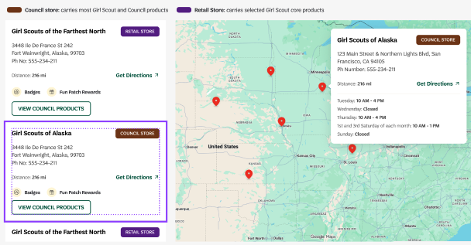

Business Questions
The tagging here will answer these questions.

- How are users engage the map?
- Which stores are clicked the most
- Are mobile users using the mapped differently than desktop users?

Implementation Details

Add data-attributes* to clickable elements

Attribute | Data Type | Requirement / Rule | Examples
data-analytics-type | string | Required. Defines the UI component style. Must use a fixed, controlled vocabulary to avoid fragmentation. | store_location
data-analytics-location | string | Required. Defines the visual zone where the element appears. Use predefined zones only. For menus, always specify context (e.g., header vs flyout). | "store_list" | "map"
data-analytics-item | string | Required. Canonical identifier for the link. Use lowercase, kebab-case slugs. Must remain stable even if UI text changes. | phone, get_directions, view_council_products, etc.
data-analytics-destination | string | Required. Target URL or action. Use relative paths for internal links. Use short action names for non-navigation actions. | /maps.google.com, /council_alaska.com

Example Code:
<a
href="/shop/new_uniforms"
data-analytics-type="nav"
data-analytics-location="header"
data-analytics-item="new_uniforms"
data-analytics-destination="/shop/new_uniforms"
>
New Uniforms
</a>

